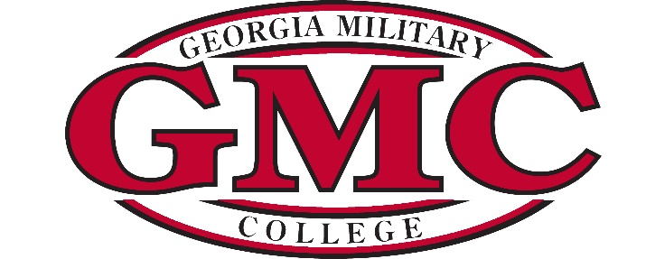

AGENDA

MEETING OF THE BOARD OF TRUSTEES
GEORGIA MILITARY COLLEGE

Tuesday, May 9, 2023
8:00 a.m.
*Teleconference

- Call to Order – Mr. George Hogan, Sr., Chairman
- Review/Approval of the GMC Mission Statement Revision – Mrs. Jill Robbins, Chief of Staff
- Next Meeting—June 20, 2023

